BOOKENDS HOSPITALITY PVT. LTD.
Internal Operations — Regulatory Readiness Series
FSSAI Schedule 4 & FDCA Compliance Readiness Report
Capiche — Vesu, Surat, Gujarat
Outlet / Brand | Capiche
Location | Vesu, Surat, Gujarat
Business Category (presumed) | Restaurant.
Report Type | Internal walk through dated 13 August 2026.
Inspection/Audit By | Vishal Patel
Report Prepared By | Nikil Malviya
Ref | Priority | What the evidence shows
S1 ★ | Critical | Licence copy on file is for the period ending 17-Mar-2026 — already expired ~5 months before the audit. No renewed copy was produced.
S2 | Flag | Bill does print a licence number, but it does not match the outlet's own licence certificate (10720031000169 vs 10725031000254).
K19 ★ | Critical | A pest (cockroach) was photographed on the floor on the audit day, despite this checkpoint being scored 2. The pest-control certificate on file is addressed to a different business name and had already lapsed for over a year.
K15 ★ | 1 evidence | Fitness certificates located for 3 staff, but all dated 08-Apr-2025 (~16 months old) — currency for the full roster still needs confirming.

Ref | Checkpoint | Rating | Priority | Remark
S1 ★ | FSSAI licence displayed and valid; Food Safety Display Board put up | Non-Compliant | Critical | 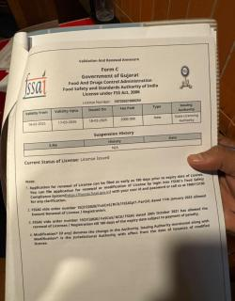  Licence has reportedly been renewed, but no printed copy was displayed on site.  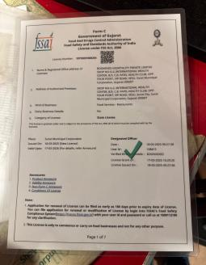

Ref | Checkpoint | Rating | Priority | Remark
S2 | FSSAI licence number printed on menu | Non-Compliant | High | 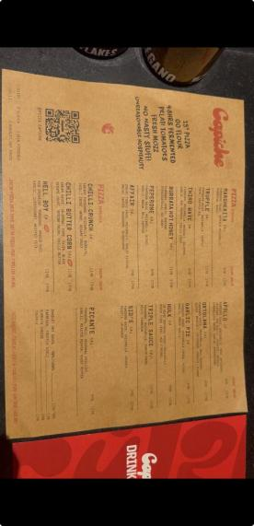
Ref | Checkpoint | Rating | Priority | Remark
S8 | Handwash or sanitiser available for guests and staff | 2 | Compliant | —
S10 | Drinking water potable/filtered; dispenser and jug clean | 2 | Compliant | —
S13 | Restrooms clean and stocked; doors do not open directly into food area | 1 | Partial | —
K18 | Handwash stations stocked — soap, sanitiser, paper towel | 2 | Compliant | —
K20 | Drain traps in place, flowing and clean; no standing water | 2 | Compliant

Ref | Checkpoint | Rating | Priority | Remark
S11 | Table condiments/sachets within expiry date; containers clean | 2 | Compliant
K1 ★ | No expired or undated items anywhere on the premises | 0 | Major | 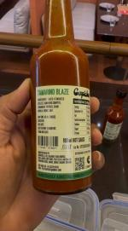  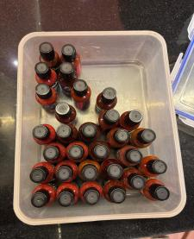  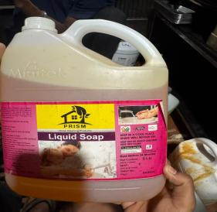
K2 | Decanted containers labelled with name and date; FIFO followed | 0 | Major | 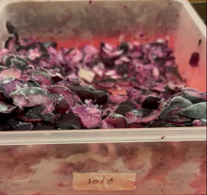  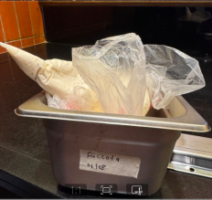  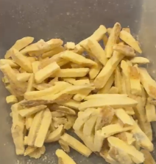  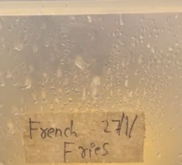  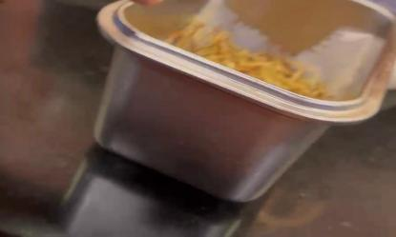
K4 ★ | Raw and cooked food completely segregated | 4 | Compliant | —
K5 ★ | Veg segregated in storage and prep | 4 | Compliant | —
K6 ★ | Chiller ≤ 5°C, freezer − 18°C; temperature log up to date | 4 | Compliant | —
K7 | Hot holding ≥ 60°C; cooking to a core temperature ≥ 75°C | 2 | Compliant | —
K8 | Thawing only under refrigeration — never at room temperature | 2 | Compliant | —
K12 | Frying oil within TPC limit; oil-change log up to date | 2 | Compliant
K14 | Only approved colours/additives used; declaration on file | 2 | Compliant

S3 | Tables, chairs and other guest-area surfaces clean and sanitised | 0 | Major | 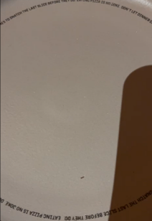  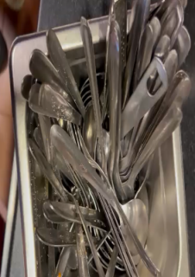  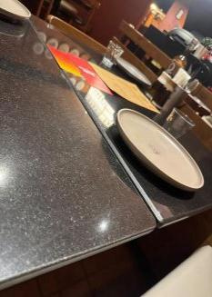
S12 | Waste bin covered, foot-operated, not overflowing | 0 | Major | 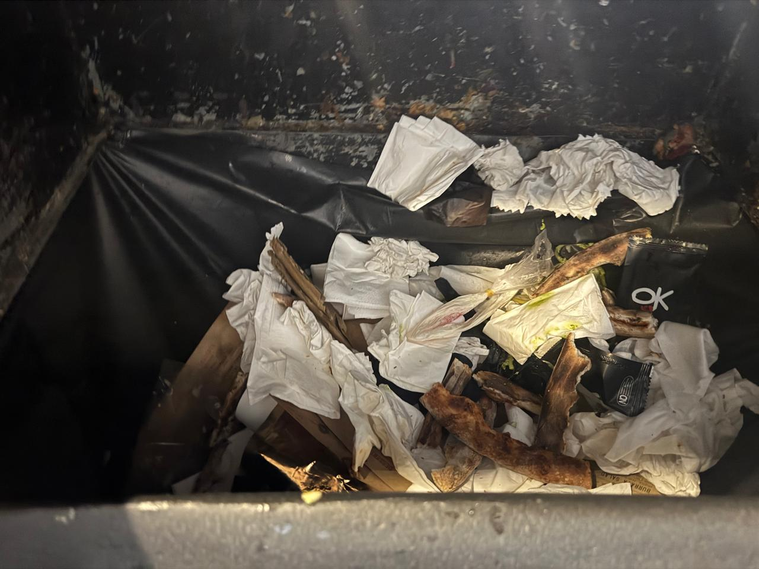
K3 | Storage 15 cm off the floor; no cartons or food on the floor. | 2 | Compliant | —
K10 | Dry store clean, ventilated, pest-free. | 0 | Major | 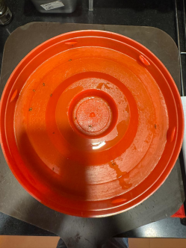
S14 | Pest barrier functional at entrance (air curtain / insect-o-cutor); no signs of pests in dining area | 0 | Major | 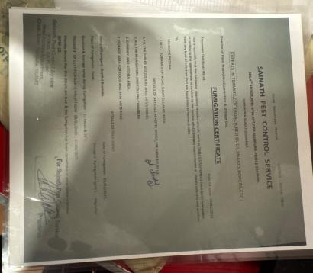
K9 | Chemicals labelled and stored away from food | 0 | Major | 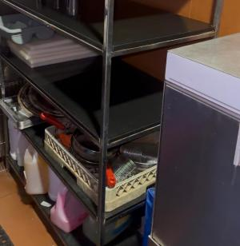  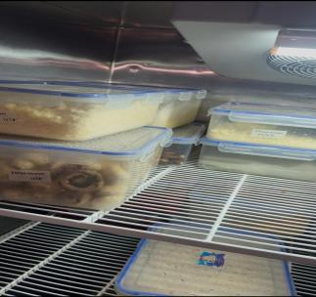
K19 ★ | No pest activity; pest-control service record up to date; stations mapped | 0 | Minor | No record paper

K21 | Waste segregated, bins covered, emptied daily | 0 | Major
S6 | Service staff in clean uniform — cap, trimmed nails, no jewellery | 0 | Major | No Cap
S7 | No unwell staff on duty; cuts/wounds covered with waterproof dressing | 2 | Compliant
S4 | Floors, walls, ceiling clean — no cobwebs, seepage or flaking paint | 0 | Major | 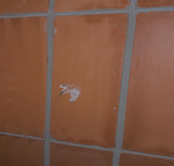
S5 | Counters and display units clean; displayed food covered and temperature-held. | 2 | Compliant | —
K11 | Colour-coded boards / separate prep tools in use | 2 | Compliant | —
K17 | Kitchen staff — cap, apron, trimmed nails, no jewellery; no smoking or paan | 0 | Major | 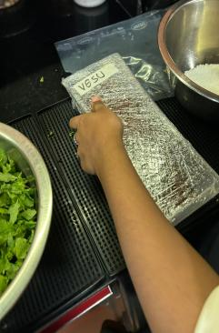  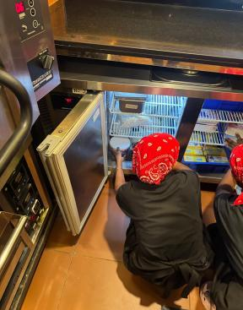
Ref | Checkpoint | Rating | Priority | Remark
S15 | Veg mark and allergen information on menu, where applicable | 0 | Major
Ref | Checkpoint | Rating | Priority | Remark
K16 | FoSTaC-certified supervisor on roster; certificate available | 0 | Major | Not available
Ref | Checkpoint | Rating | Priority | Remark
K23 ★ | Water potability report valid — tested within the last 6 months | 0 | Critical | Team reports an informal daily check is done, but there is no documented report; the formal 6-monthly lab report has not been renewed.
K24 | Deep-cleaning schedule up to date and followed; dispense log with temperature (CK checklist) | 0 | Major | 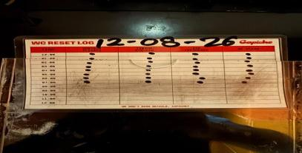
S9 | Crockery, cutlery and glassware clean, chip-free, stored covered. | 0 | Major | 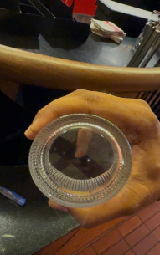

Ref | Checkpoint | Rating | Priority | Remark
K15 ★ | Medical fitness certificate up to date for every food handler | 0 | Major | 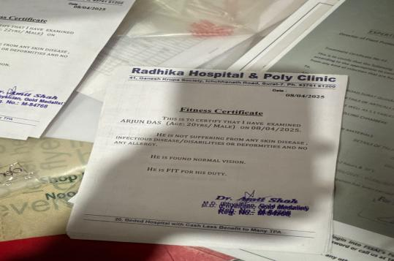
K22 | Exhaust and hoods degreased; ventilation adequate; lights protected | 0 | Major
K13 | Food-contact surfaces and equipment clean — no rust, damage or wooden patches | 0 | Major

Score & Grade
Section | Available marks | Obtained marks | %
A — Service Area | 32 | 11 | 34.4%
B — Kitchen Area | 62 | 28 | 45.2%
Total (Overall) | 94 | 39 | 41.5%
Grade: Non-Compliance — on the Schedule-4 FSO inspection grading bands (Exemplar ≥ 90%,

Conclusion
- Overall standing — 39/94 (41.5%), which falls in the Non-Compliance band. All 39 checkpoints were rated: 16 Compliant, 1 Partial and 22 Non-Compliant. Section A (Service Area) scores 34.4% and Section B (Kitchen Area) 45.2%.
- Criticals are the priority — 5 of the 8 ★ criticals are Non-Compliant (S1, K1, K15, K19, K23); only K4, K5, K6 — segregation and cold-chain control — hold. These 5 carry 20 marks between them, so closing them alone lifts the score to 59/94 (62.8%) and back into Needs Improvement.
- Failures cluster in two areas — housekeeping and cleaning (S3, S4, S9, K10, K13, K22, K24) and documentation (S1, S2, S15, K15, K16, K23) account for 13 of the 22 Non-Compliant checkpoints. The documentation set is paperwork that can be closed quickly; the cleaning set needs a scheduled deep-clean with sign-off.

